1. What is API testing.

[API testing](https://www.edureka.co/blog/what-is-api-testing) is a type of software testing where application programming interfaces (APIs) are tested to determine if they meet expectations for functionality, reliability, performance, and security. In simple terms, API testing is intended to reveal bugs, inconsistencies or deviations from the expected behavior of an API.

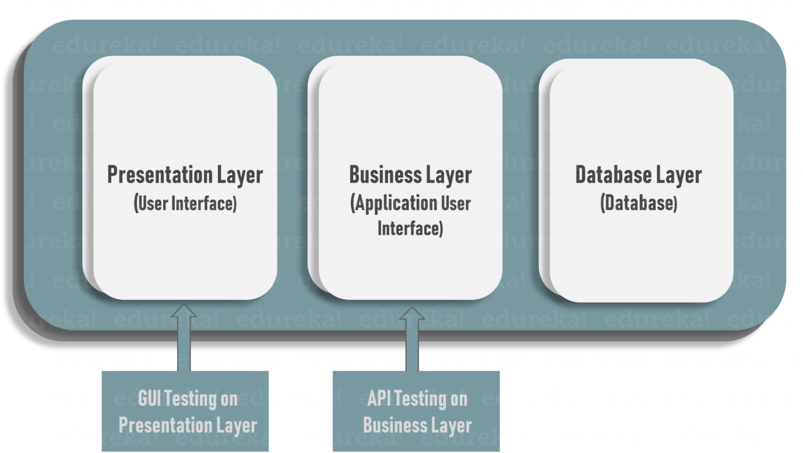

Commonly, applications have three separate layers:

* Presentation Layer or user interface
* Business Layer or application user interface for business logic processing
* Database Layer for modeling and manipulating data

API testing is performed at the most critical layer of software architecture, the Business Layer.

<https://www.edureka.co/blog/interview-questions/manual-testing-interview-questions/>

1. hahah